vBulletin 5 Connect
Quick Start Guide (ver 1.0)

Written and Maintained by Internet Brands

Introduction
Congratulations on successfully installing your new vBulletin site! If this is your first time using one of our products (or vBulletin 5), this guide will help you get things set up. Let’s begin with a few definitions.

When you first install your vBulletin, your site loads with the preset style and page like so:

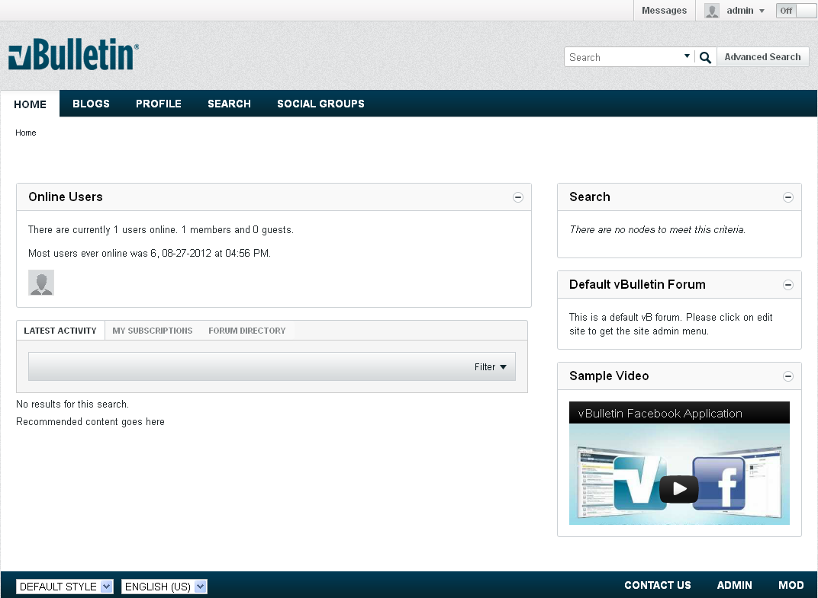

As you can see, it’s already been pre-populated with a page and some modules. A page is exactly that, a page. It displays your site to users and is a container for modules. Modules are pieces of functionality that you can add, customize, and, sometimes, remove from a page. These modules can cover such functionality as displaying ads, to announcements, to videos and even videos.

Everything in vBulletin 5 is a module of some type. There are two types of modules: normal modules and system modules. The main difference between the two is that you’re unable to delete system modules. This is functionality that you wouldn’t want removed from your site to begin with, such as private messages, advanced search and registration forms.

Now that we have the basic terms down for vBulletin 5, we’ll move on to the how they work and how you can use them, starting with creating pages.

Table of Content
Introduction
Editing and Creating Pages
Add Modules Tab
Change Layout Tab
Select Template Tab
Color Style Tab
Saving the Changes
Adding a Page
Linking to the a New Page
Creating Your First Forum and Subforum
Adding a Forum
Creating a Category
Adding a Sub-Forum
Creating a Private Forum
Setting Up User Registration
Setting Up Human Verification
FAQ
How do I change my username?
How do I change my password?
How do I change my logo?
How do I change the default style?
How do I add my own ads?

Editing and Creating Pages
You can edit all default pages in addition to adding more pages to meet the needs of your site. In order to edit an existing page, activate the Site Builder by click on the the Off button in the upper right hand corner of your navigation bar.
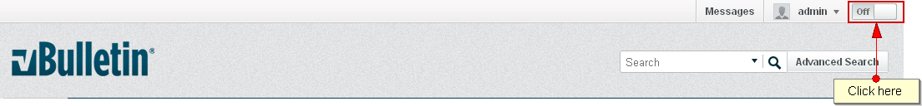

Once you’ve activated the Site Builder function, navigate to the page that you want to edit and click Edit Page button.

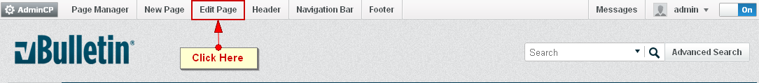

This opens a form like the one below.

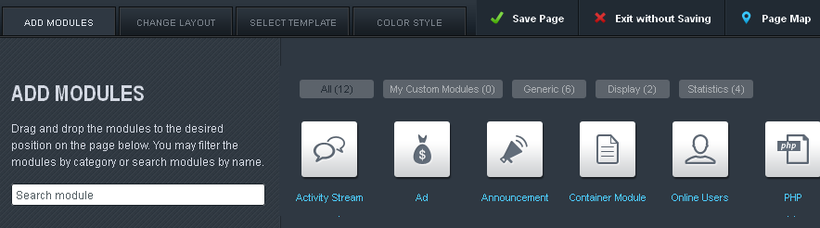

Add Modules Tab
There are four tabs in the form. The first (the Add Modules) is a catalogue of modules that you can add to the selected page to customize the look and feel of it. Each, as we mentioned, has a different function. Here’s a short list of what they do:

- Activity Stream - A module that tracks and displays the activity on your board. Also contains the directory for any channels created on the page.
- Ad - A module that organizes and rotates the ads on a site.
- Announcement - A module that manages and displays announcements and notices to your users.
- Container Module - A module that other modules are moved into so regular users can interact with them but moving or minimizing its contents.
- Online Users - A modules that displays the number of users online at any given time.
- PHP - A module that displays PHP entered in it.
- Search - A module that displays a customized set of search results as a feed.
- Static HTML - A module that displays custom HTML.
- Tag Cloud - A module that displays a clickable list of tags used on the site.
- Today’s Birthday - A module that displays the usernames of user’s with birthdays on any given day.
- Top Active Users - A module that displays a list of the top active users.
- Video - A module that embeds a video on to a page.

To put a module on a page, click and drag it from the menu onto the page itself. You can use the same method to rearrange the order of the modules on a page. To delete a module, click on the trash can icon to the right of the module title. To edit the module, click on the pencil. A form will open similar to the one below:

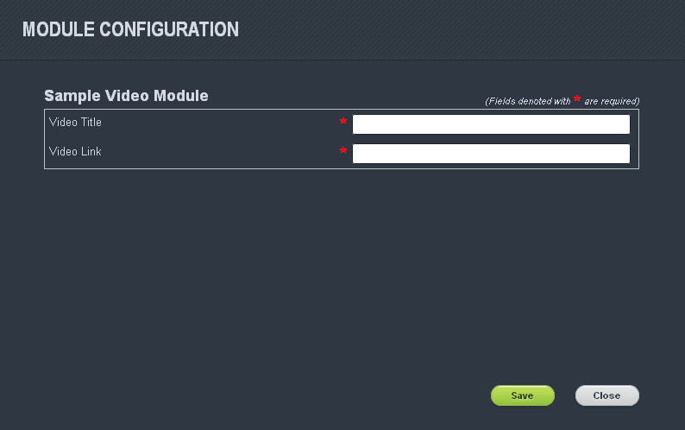

A number of fields will be available in the form for you to edit and change. To save the changes you have made for the module, click on the Save button at the bottom of the page.

For more information on what the options for each module does, visit our online help at: https://www.vbulletin.com/docs/html/sitebuilder_modulelist

Change Layout Tab
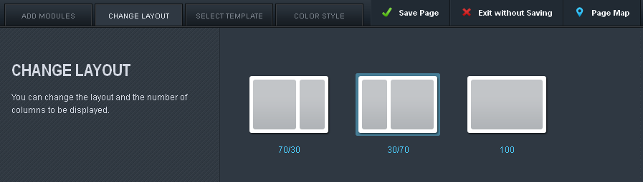

The Change Layout Tab is the second of the four tabs. This controls the number of columns on a page and the percentage of space each column takes up.

Select Template Tab
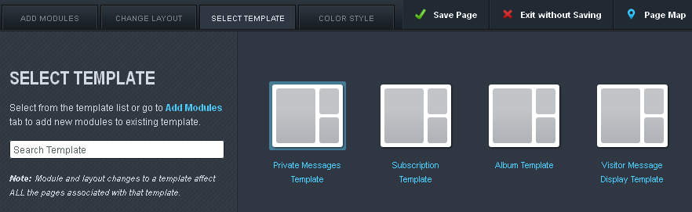

Templates are the saved designs for the default pages and any pages that you create. This can be especially helpful when you have several pages using the same template that requires a change that affects them all.

Color Style Tab
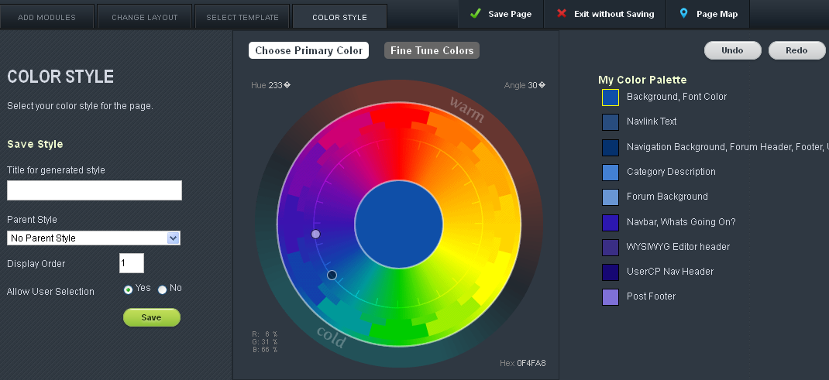

The Color Style Tab allows you to the limited ability to change the style for the page you’ve selected. Using a combination of the color wheel and the My Color Palette, you have a limited control over how the page looks like. A preview of the page will appear beneath the form and the save button in the left hand column allows you to save the Style you’ve created to reuse at a later date.

Saving the Changes
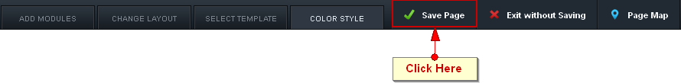

Once you’re finished modifying the page, click on the Save Page button to the right of the tabs. It opens a confirmation form where you have the option of saving the page as a new Template or overwriting the existing Template.

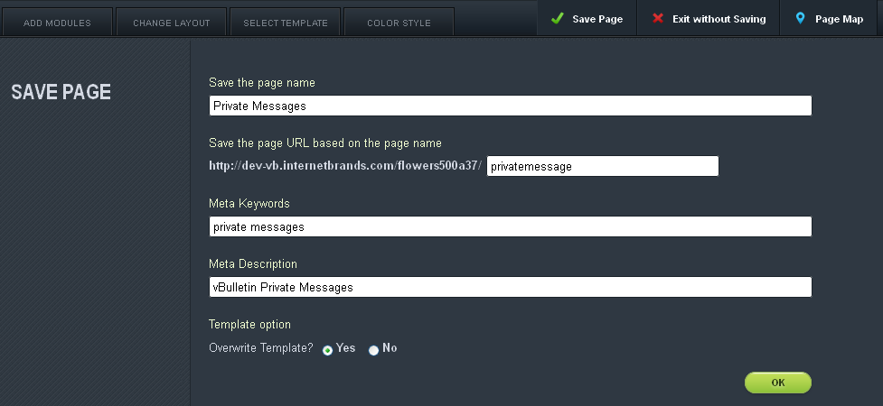

If you choose to overwrite the existing Template, you won’t be able to retrieve the old design if you want to switch back at a later time.

Adding a Page
To add a page to your site, follow the same steps as we listed at the top of this section, but! Instead of clicking on the Edit Page button, click on the New Page button instead.

Linking to the a New Page
To link your newly created page in the navigation bar, navigate to the page and copy the address to your clipboard. Click on the Navigation Bar button. A form like the one below will open:

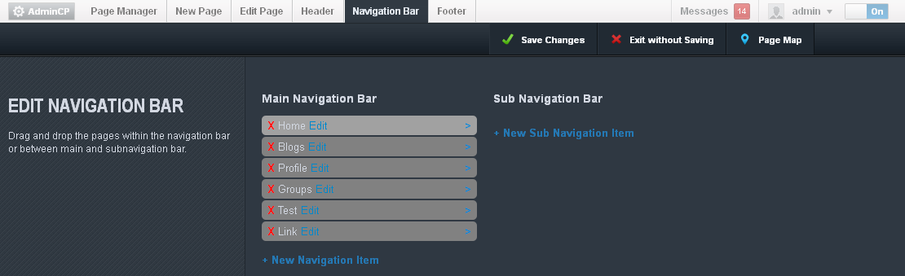

Decide if you want the link to be a main navigation item or a sub-navigation item. If the link is a sub-navigation item, click on the carat to the far right of the main navigation item you want it nested beneath. Click either the New Navigation Item or the New Sub Navigation Item.

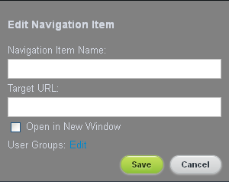

Enter in the name of the link in the Navigation Item Name field and then paste the address your copied into the Target URL before clicking the Save button. Once that’s one, your link will appear in column it was added to. To change it’s position, click and drag it to its new location.

Finally, click Save Changes and confirm your changes. If you do not take this step, the changes will be lost.

Creating Your First Forum and Subforum
Your vBulletin installation comes with a pre-generated forum. To add more forums, turn on your Site Builder and click on the Page Manager button. This opens a form like the one below:

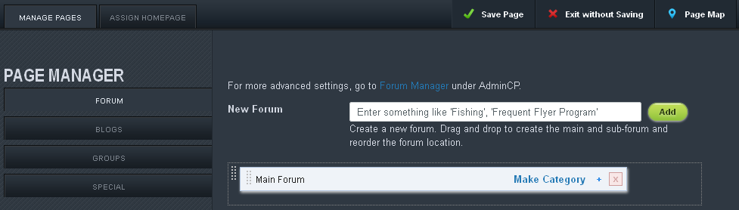

Adding a Forum
From here, enter the name of the of forum you want to create in the New Forum text box and click Add. It will appear beneath the pre-generated Main Forum. You can change it’s position by clicking on the dotted strip to the left of the forum name and dragging it to its new location.

If you want to delete the forum, click the red x icon to the right of the plus symbol. A confirmation popup will appear. Clicking Yes will complete the deletion. Be careful of which forums you delete, since any threads, posts, and replies in that forum will be removed along with its parent.

Creating a Category
A category is a container for forums and largely used to organize the forums into, well, different categories. To make a category, click on the Make Category link to the right of the forum you wish to be a category. It will be instantly changed to a category. If you want to change it back, just click the Make Forum link that has taken it’s place. It’s that simple.

Adding a Sub-Forum
Sub-forums are forums that are nested in parent forums. Usually, this is used to create an area for specific aspects of the topic covered by the larger forum to be discussed. If you want to create sub-forum, click on the plus symbol between the Make Category link and the red x icon. A field such as as the one below will appear:

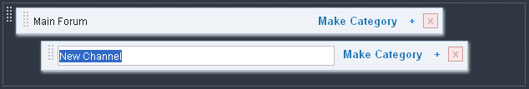

Enter the name of the new forum in the field that reads New Channel before clicking away from the sub-forum. It’s that simple.

Creating a Private Forum
Now that you have your forums set up, you might want to change the permissions on them. Permissions tell the system which users get to see what. By using permissions, you can create a private forum for your users to use.

To do this, click on the AdminCP button in the upper right hand corner of the Site Builder menu.

Please note, you may be asked to log in again for the same reasons that you had to provide your password a second time. The window will reload to a page similar to this:

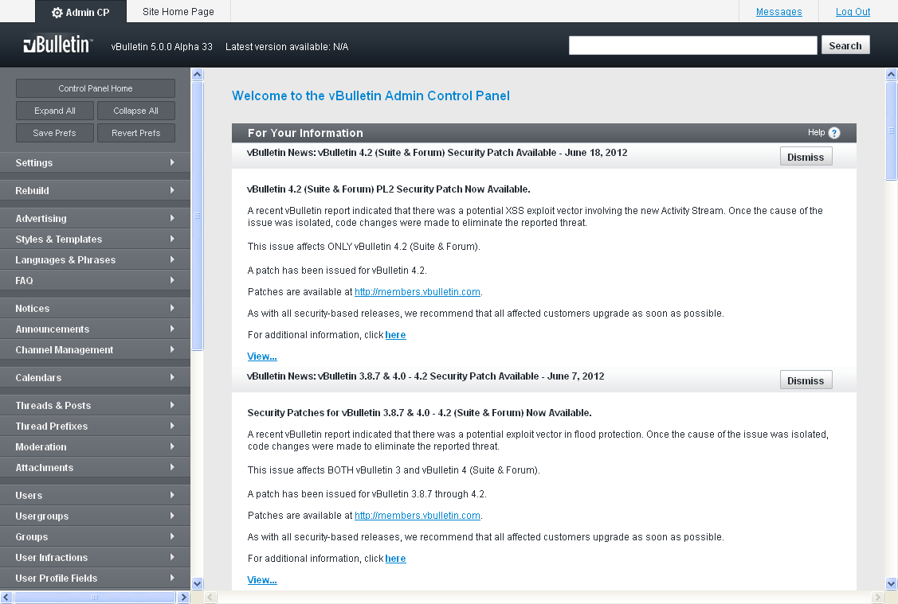

Scroll down to the Channel Management header and click it. Select the Channel Permissions option and click it.
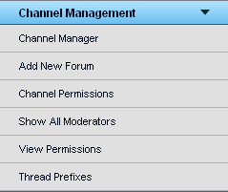

This will reload the frame to the right with a form like this:

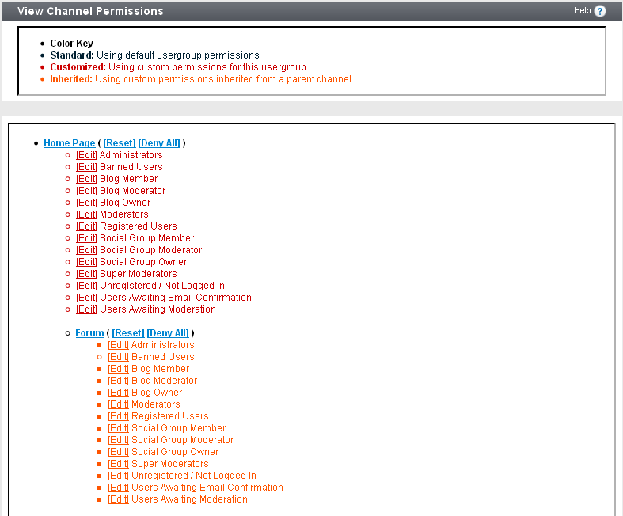
Select the Edit link beside the usergroup you want to hide the forum from. This will open another form with several options:

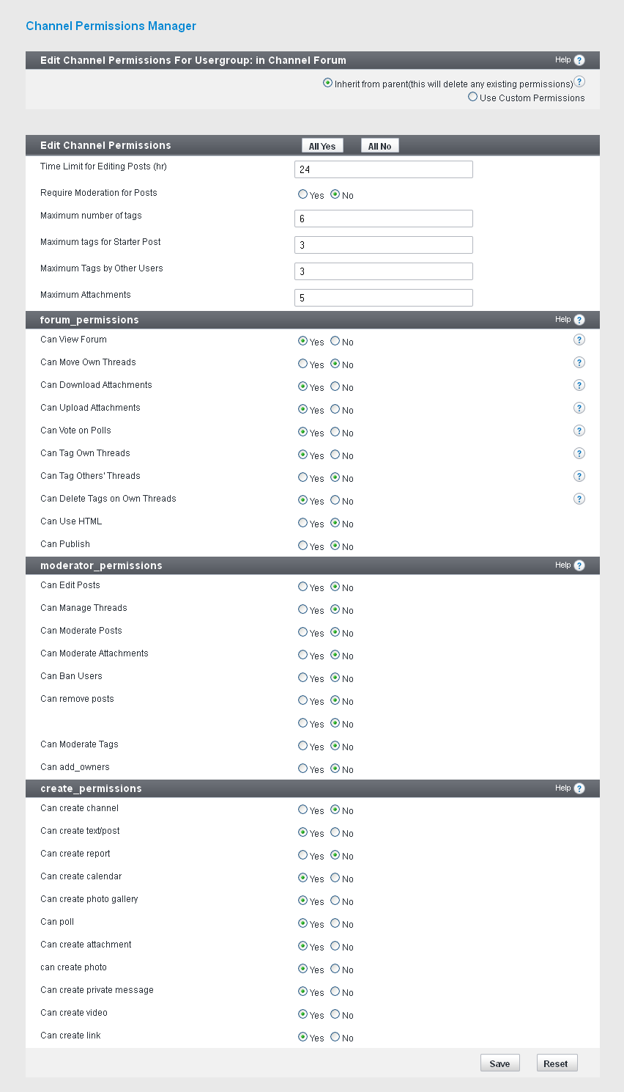

Find the froum_permissions header and change the Can View Forum setting to No before clicking Save. The usergroup that you selected will no longer be able to see that forum.

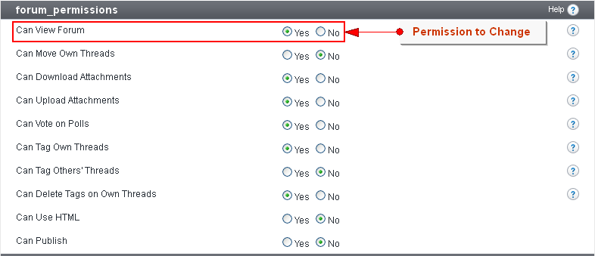

Setting Up User Registration
With everything set up for your site, it’s now time to take a look at your User Registration settings. Stay in the AdminCP and click on the Settings header, followed by the Options link.

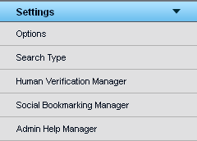

Once the vBulletin Options form loads, select the User Registration Options from the scrolling list and click the Edit Settings button:

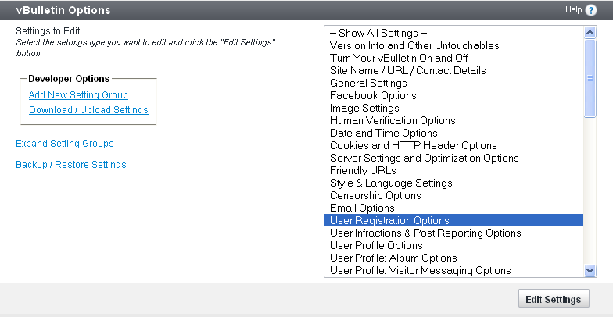

The following form will load:

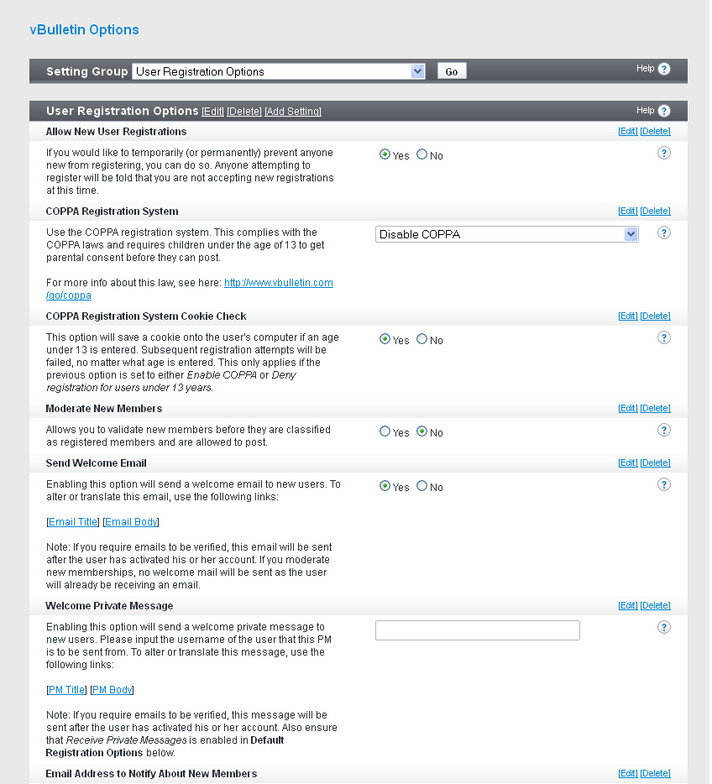

This controls every aspect of user registration for your site. It includes everything from whether or not it’s turned on, to COPPA Registration, to Welcome Messages. For a full list of options and what they do, go to:
https://www.vbulletin.com/docs/html/main/acp_settings_options_userregistration

Setting Up Human Verification
There are some sections of the site and its functionality that you’ll want to have human verification for. To turn on Human Verification, click on the Settings header in the AdminCP, followed by the Options link.

Once the vBulletin Options form loads, select the Human Verification Options from the scrolling list and click the Edit Settings button:
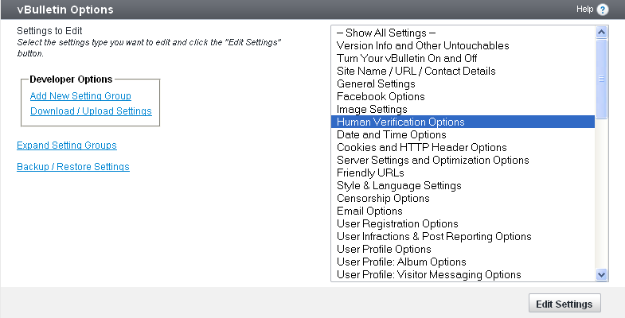

This reloads the frame with the following form:
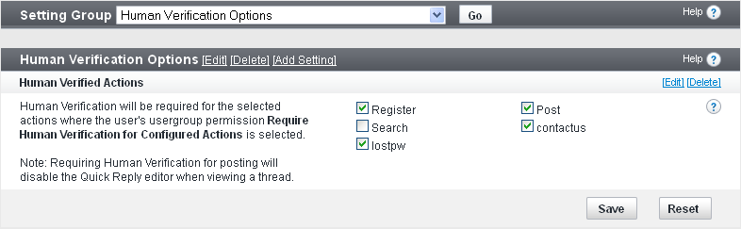

Checking an option will activate it, while unchecking the option will deactivate it. This means that any usergroup that has the option Require Human Verification on Configure Actions activated will need to verify that they’re human when interacting with the selected options. Once you’re done, click Save and the changes you’ve made will be applied to the site.

FAQ

How do I change my username?
To change your username, login to the AdminCP and click on the Users header. In the menu, click on Search for Users. In the new form in the frame to the right, enter your current username in to the User Name field and click the Exact Match button. In the User Form, change the username in the User Name field and click Save.

How do I change my password?
On your Site Home Page, click on the Profile tab. Find the Edit Settings button beneath your user picture and click on it. This will reload the page with the Profile Settings page. Click on the Account tab and scroll down to the Password fields. Enter your current password in the field with the words ‘Enter current password’ and your new password in both the fields below that. Click Save Changes and your password will be set to the new password.

How do I change my logo?
To change the logo of your site, make sure your Site Builder is turned on and click the Header button in the menu. Find the vBulletin logo and click the Edit button in the upper left hand corner. This will open an upload form which you can use to replace the current logo with another of your liking. Once you’ve uploaded the new logo, click on the Save Changes button. The site will reload with the new logo.

How do I change the default style?
To change the default style for a page, login to the AdminCP and click on the Settings header. Then click on Options then select the Styles & Language Settings option from the new form. This will take you to the selected form. From here, find the Default Styles section and select a new default style from the dropdown list. Click the Save button at the bottom of the form and your changes will be saved.

How do I add my own ads?
To add your own ads, turn on the Site Builder option and add the Ad Module to the page you want the ads to appear on. Click on the Edit button for the module and fill out the form before clicking Attach. This will take you to a new form where you can arrange the order in which the ads appear or add new ads.

Once you’re done, click the Save button on the Ad form and confirm the changes on the page by clicking the Save Page button. The ads should now appear where you placed them.

You’ll be asked to re-enter your password for security purposes. Using Site Builder will change the look and feel of your site dramatically and this is to ensure that no one, but you, can do this.
For a more thorough explanation of permissions, go here: https://www.vbulletin.com/docs/html/main/acp_permission_overview_overview

